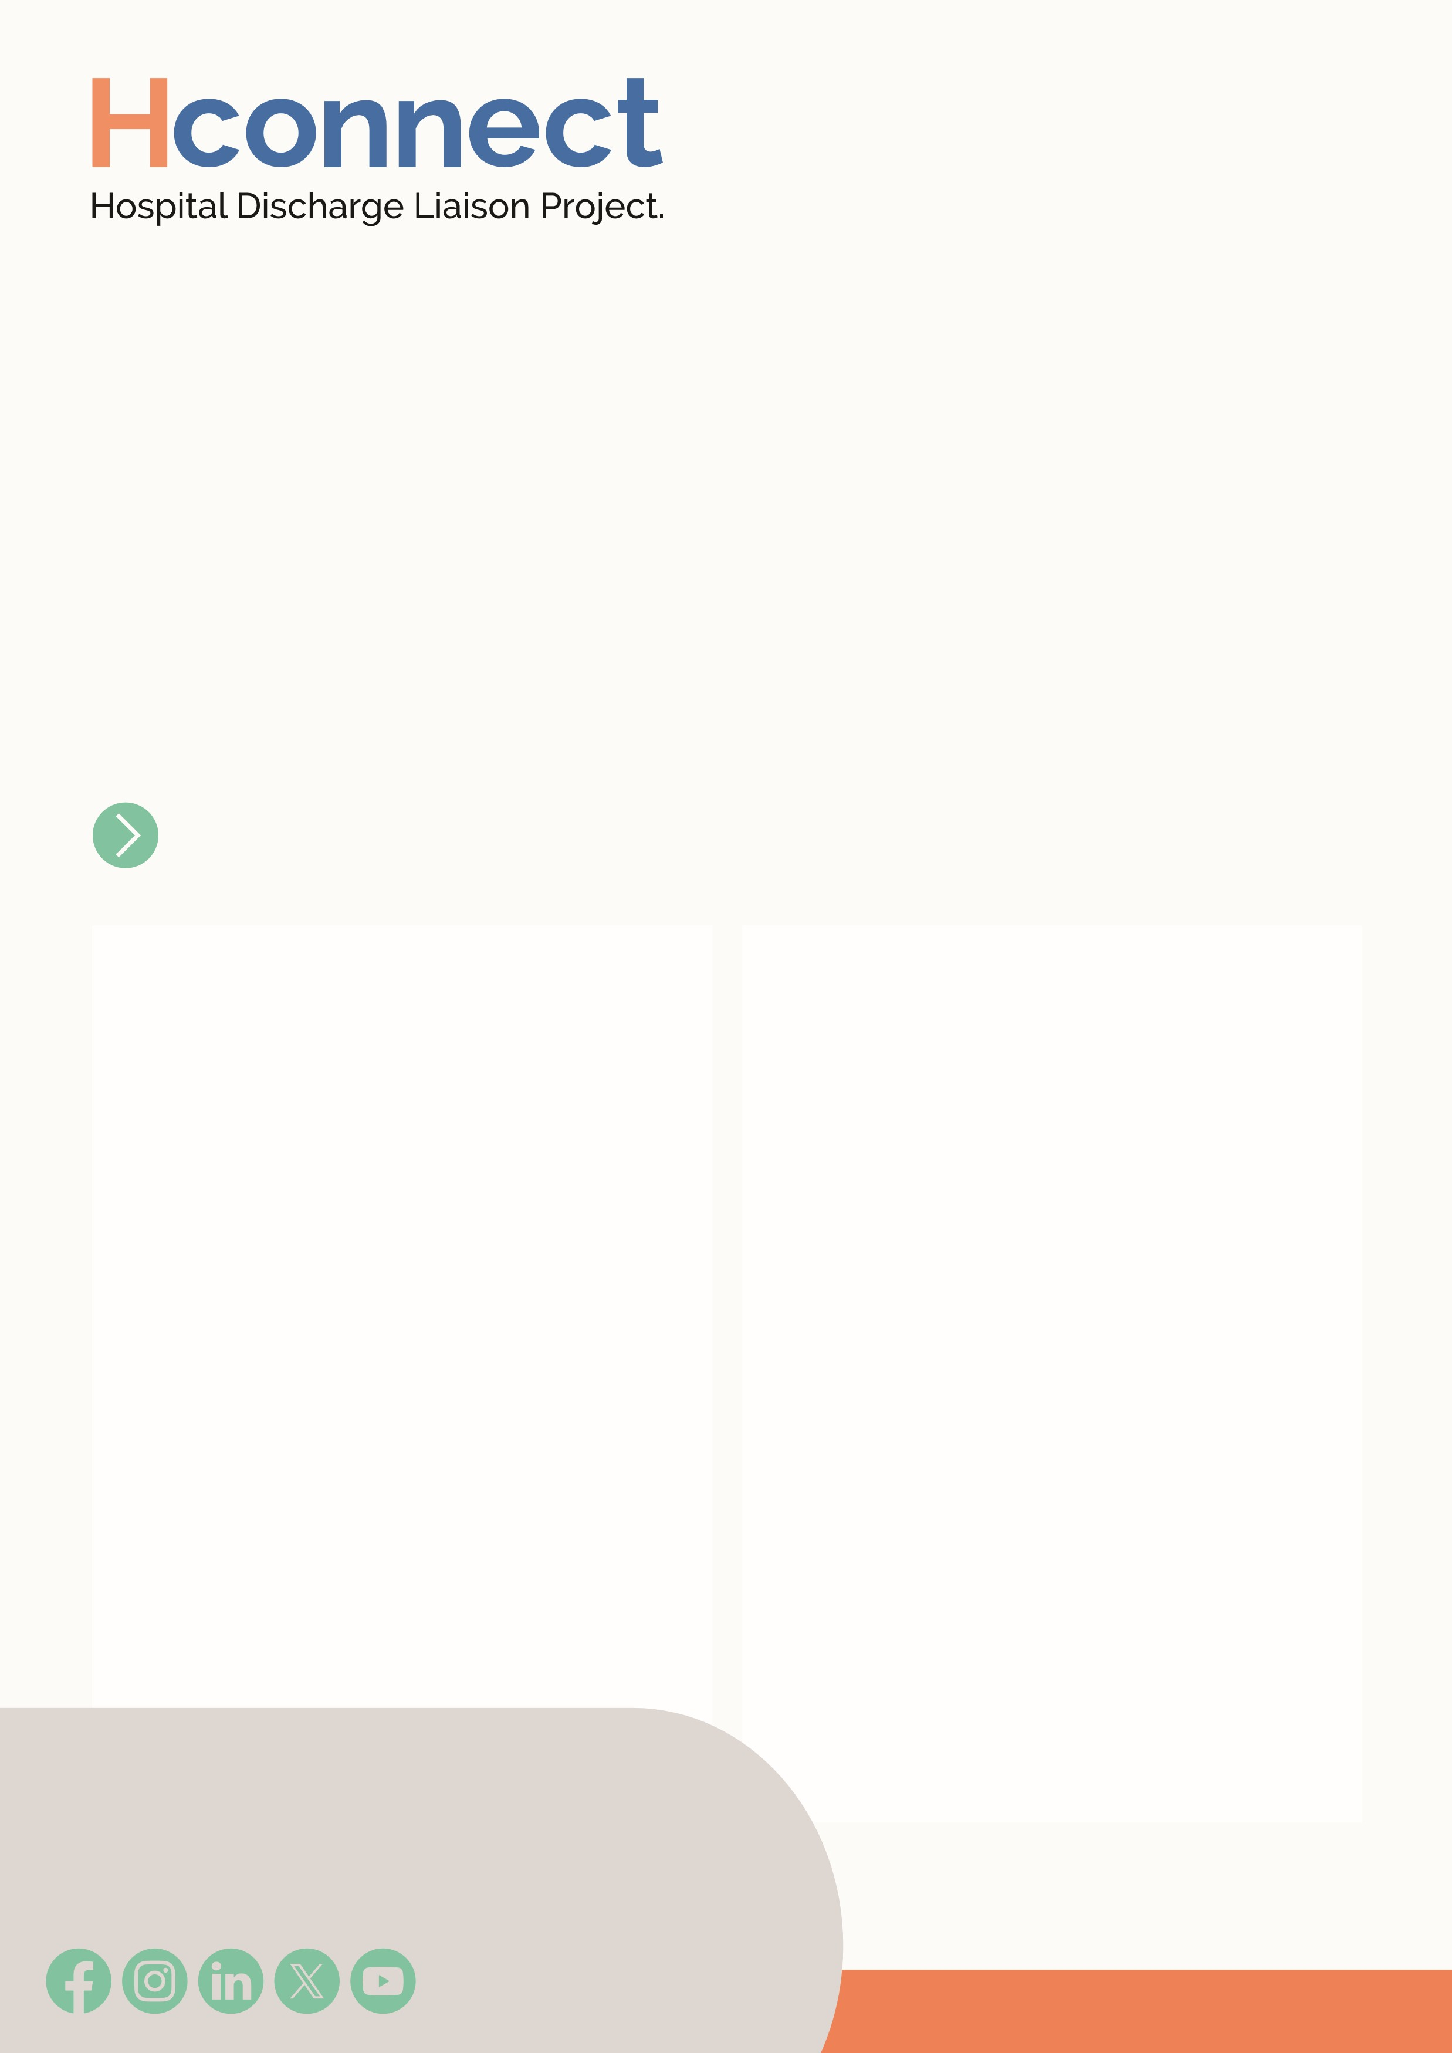
Top Tips for Creating a Carers Information Board
A clear, well-placed Carers Information Board is vital to ensuring unpaid carers have access to clear, informative and accessible information to support their caring role and promote their health and wellbeing. To be effective, the board should be eye-catching and placed somewhere high-traffic like a ward corridor, waiting area, or near patient rooms, where people are likely to see it.

Make it Relatable
Use questions to grab attention, like: “Do you look after someone?” or “Does someone help look after you?” These prompt recognition without relying on the word carer.

Include Essential Information
- Hospital Info: Include visiting hours, patient principles, pharmacy contacts, carers passport info and department contact details.
- Carer Champions & Leads: Add photos, contact details, and brief role descriptions.
- Carer Support Services: Include local service leaflets, carer assessments, respite care, and mental health support.
- Key Contacts: List Social Workers, Care Coordinators, and other relevant staff.
- Local Support Networks: Highlight guidance and advice for carers.
- GP Carer Registration: Explain why registering with a GP as a carer is important.

01773 833833
hconnect@derbyshirecarers.co.uk
- Emergency Card: Include info on contingency planning and the Carers Emergency Card.
- Health & Wellbeing: Offer tips on nutrition, sleep, stress management, and local wellbeing groups.
- Discharge Info: Add information on Discharge to Assess (D2A) and relevant pathways.

Presentation Matters
- High-Visibility: Place the board in a busy area (e.g. waiting rooms or near patient bays).
- Clear Language: Use simple, culturally appropriate wording—avoid jargon.
- Visual Layout: Use clear headings, subheadings, and a tidy structure.
- Accessible: Make content easy to read and consider visual impairments.
- Keep It Fresh: Review and update info regularly to stay relevant.

Supporting Carers Through Hospital Transitions
www.derbyshirecarers.co.uk

www.derbyshirecarers.co.uk

